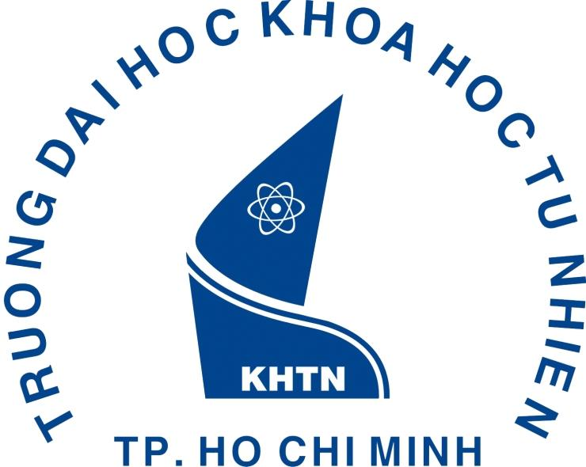
Interviewee Information Form
Hanyang University
Name | _______________________ | Gender | - Male  - Female
Name | _______________________ | Nationality
Currently  Study Status | - Student  Diploma currently pursuing  □ Bachelor □ Master □ Doctor  University: _________________________________________________  Department: ________________________________________________
Currently  Study Status | - Non-Student  Highest diploma obtained  □ Bachelor □ Master □ Doctor  University: _________________________________________________  Department: ________________________________________________
English and Foreign Language proficiency | - □ Advanced □ Intermediate □ Beginner  - English test name, score, date:  - Others:
Contact info | Email address & phone no.:
Proposed program for study at HYU | - Department/institute:  - □ Bachelor □ Master □ Doctor  - Fields/research topics:

Evaluation (THIS SECTION FOR HYU USE ONLY)
Decision | Issued admissions already
Decision | Can’t decide, but highly recommend to the pointed department/institute
Decision | Not recommend
English proficiency (scale 1-10) □1 □2 □3 □4 □5 □6 □7 □8 □9 □10
Other comments:

HYU Professor’s Name:
HYU Professor’s College / Department:
HYU Professor’s Signature:

